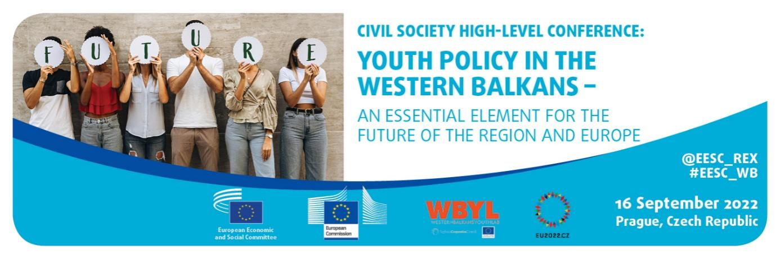
EN

Conclusions of the High-Level Civil Society Conference on Youth Policy in the Western Balkans – An essential element for the future of the region and Europe - 16 September 2022, Prague, Czechia

The participants:

- called for the immediate stop of the Russian aggression, the suffering of the civilian population and the destruction across Ukraine, as well as on the leaders of the Western Balkans governments to strongly resist Russian influence that tries to destabilise the Western Balkans;

- called upon the Czech Presidency of the Council of the EU, as well as all presidencies that will follow, to keep the EU enlargement to the Western Balkans very high on the EU agenda and to take, in close cooperation with the governments in the region and to the benefit of the citizens, concrete steps towards EU accession (including granting visa liberalisation for the citizens of Kosovo⃰). At the same time, great attention should be paid to fulfilling EU commitments throughout the process as EU can’t afford the Western Balkans to be an example of a failed EU accession process;

- called upon the EU institutions to further advance the gradual integration between the EU and the Western Balkans, all while placing particular emphasis on youth policies, among other relevant policies;

- called for active inclusion of young people in the EU accession negotiations and the enlargement process, as well as raising awareness about the process among the youth. Young
people should be looked upon as the primary agents of change for the whole region;

- recognized the benefits of regional cooperation and cooperative frameworks in promoting and advancing the youth agenda, EU perspective and overall benefit to societies;

- acknowledging the progress in developing sound youth policy frameworks, invited Governments of the Western Balkan partners to further invest in evidence-based youth policies addressing youth development challenges;

- in order to ensure successful sustainable development in local communities, believe it is crucial that institutional, programme and policy developments are grounded in young people's views on human development;

- are convinced that sufficient and transparent budget allocations for youth policy development are a prerequisite for facilitating positive changes and improving the situation of young people;

- invited Western Balkans governments to follow key youth policy documents of the European Union (EU), to further develop youth policies and to enable young people to participate in the design of policies, taking note of the good practice of Youth Labs implemented through the Western Balkans Youth Lab project under the Regional Cooperation Council (RCC) umbrella and inspired by the EU Youth Dialogue; better inclusion of the Western Balkans in the EU Youth Dialogue is highly recommended;

- believe that systematically collected high-quality youth sensitive data are a prerequisite for informed policies and support measures for young people, especially vulnerable groups of young people. In particular, the system for collecting and processing data related to the social dimension of youth participation needs to be significantly improved;

- in addressing the fight against poverty and improving the quality of education, are of the view that it is key to involve social partners and civil society organisations (CSOs) in order to deliver a broader reform to improve social rights and the prospects of young people. Social partners and other CSOs should have a greater role in the dialogue on social and economic reforms. Direct support from the EU should ensure the views of social partners and CSOs are taken into account, including in fighting violence at the working place;

- called for the reinforcing of EU programmes and regional structures, with the aim of reaching more young people in the Western Balkans by providing them with the opportunities for education, mobility, volunteering and employment;

- called for a stronger focus on vocational education and training, by combining apprenticeship schemes with academic learning at secondary and tertiary level;

- believe that close collaboration between education and training policy and the business community must be enhanced and focus should be placed more on competences than qualifications;

- welcomed the Economic and Investment Plan (EIP) for the Western Balkans, calling for the improvement of labour market participation, especially of young people and women, disadvantaged groups and minorities, in particular Roma. The implementation of the EIP should maximise the benefit for young people;

- called on all regional initiatives and agendas, such as the Common Regional Market and Green Agenda for the Western Balkans, to further increase the inclusion of youth voices across the agendas;

- acknowledging the importance of digital and green transition, called upon the need for an enhanced inclusion of youngsters and vulnerable groups in digital upskilling and reskilling activities as well as greater exposure to regional debates on green agenda;

- called for the Youth Guarantee in the Western Balkans to be implemented following the Council recommendations on a reinforced Youth Guarantee;

- in order to implement a Youth Guarantee in the Western Balkans, called for increasing the capacities of the public employment services (PES) and their staff in the region taking note of the good practice of regional PES bench-learning implemented through the Employment and Social Affairs Project under the RCC umbrella and inspired by the EU PES bench-learning model;

- drew attention to the importance of cooperation between various partners to address the issue of youth unemployment. Partnerships should be established across all levels of government, between Youth Guarantee providers and relevant stakeholders, such as social partners, educational and training institutions, youth organisations and other CSOs;

- called upon the European Commission to foster and incentivise EU direct investments in the Western Balkans, not only to strengthen local economies and offer compelling job opportunities for educated young people, but also to increase internal pressure in the areas of equal opportunities, rule of law, anti-corruption and corporate social responsibility;

- suggested substantially increasing the effort to offer young people from the Western Balkans the access to university education in the EU. New scholarships and/or loans within or outside the Erasmus+ scheme that can be annulled after the beneficiary returns to the country of origin would establish an effective tool to counter brain drain. At the same time, they are expected to increase the qualification of the workforce in the region and provide the government with qualified human capital that is essential for good governance and successful accession process;

- believe that attention and support should be given to the capacity building of social partners and the development of social dialogue and collective bargaining in order to mitigate precarious working conditions and improve the quality of jobs and quality of life;

- also called on the social partners of the Western Balkans, at all levels, to actively involve young people in all their activities, including collective bargaining;

- taking into account the possibilities of the European Year of Youth proclaimed for 2022, are convinced that addressing the challenges facing young people and bringing Europe closer to young people should be an approach not limited only to young people living in the EU; it should also apply to young people from all Western Balkans partners;

- encouraged the EU and our partners from the Western Balkans, in line with the EU Youth Strategy, to introduce a youth impact assessment tool, so-called Youth Test. This Youth Test would ensure that young people are considered during policy-making processes, it would enable to create better targeted policies and to identify any mitigation measures necessary to avoid negative impact on young people;

- believe that efforts are required from the Governments of Western Balkan partners in setting regional cooperation as a policy priority. In supporting this transformation and advancing regional cooperation as a policy priority, the EU should support the Western Balkans in identifying key areas and avenues which could foster changes for citizens of all Western Balkans, especially for young people;

- since the Conclusions of the 2021 Western Balkans Summit in Berlin of the Berlin Process underline the need for strengthening youth organisations and networks, invited the European Commission to further examine new ways to support relevant youth structures e.g. national youth councils and youth umbrella organisations in the Western Balkans, on a regional level, as well as continue supporting them through already existing mechanisms;

- called for structured regional dialogue between youth structures and government administrations focused on jointly developing policies which will increase youth participation in decision-making for main issues affecting young people, i.e. unemployment, environment, digitalization, mental health, innovation, etc;

- believe that further efforts to strengthen the political education and representation of young people are needed, both through mainstream politics and through youth structures e.g. national youth councils, local or municipal councils and therefore invite the institutions of the EU to further support the Western Balkans in improving youth participation;

- welcomed the fact that the Innovation Agenda for the Western Balkans envisages further actions to support their involvement in all EU's programmes covering research, innovation, education, culture, youth and sport. Taking into account the positive correlation of educational or training mobility with the civic and political engagement of young people, further efforts in this regard may lead to the advancement of youth participation and engagement;

- reiterated the importance of young people for the future of the Western Balkans and therefore the importance of taking concrete measures to turn the region into a place with future prospects and opportunities for young people, enabling them to stay and prosper. Timely involvement of young people in the co-design and co-implementation of social and political changes is extremely important.

_____________

⃰ This designation is without prejudice to positions on status, and is in line with UNSCR 1244/1999 and ICJ Opinion on the Kosovo declaration of independence.

